Design of Web

**Abstract:**

In the coursework, I designed a web which includes Announcement module, Learning module, Problem module and User module. And this web is a functional web, so I designed a simple style and I considered the accessibility and usability as much as possible.

There are 1 CSS file, 46 HTML files and 6 images in the coursework.

**Wireframe model of page layout and descriptions:**

46 HTML files can be divided into 7 categories.

1. **Index**:

Filling block

Filling block

Contents

Navigation System

Announcement

**Design ideas:**

**Navigation:**

When the web page slides down, the Navigation keeps the navigation bar is always at the top of the page.

**Filling Block:**

This design has two functions.

First, it takes up space and makes the Content Block at the center of the web page.

This is not important function, because using some attributions also can finish this job.

Second is making the web page be more flexible and easier to make some change.

E.g.



The blue arrow is placed on the right Filling block. And through clicking it, it will go to the top of web page.

**Content:**

The main content will be placed in there.

This is a Box of Box-margin-padding Model.

**Announcement:**

Announcement title and content

“Announcement”

Speaker and time

1. **Problem**:

Content

Problem List

Filling

Filling

Navigation system

Page navigation

Search box

**Design ideas:**

**Content**:

Search box

Page navigation

Problem list

In this part, Box Model is used.

1. **Learning:**

navigation

Filling

Filling

content

This page is like index.

1. **User:**

Navigation

User card

Release record

User Information

1. **Question page:**

Content

Filling

Filling

Navigation

Design ideas:

**Content:**

Description of question:

Answer area

1. **Judge:**

Loading animation

Navigation

This page is a transition page. And after three seconds, the web will go to the VIP page.

1. **VIP:**

Navigation

VIP description

Because the coursework just is a static page, some function cannot be implemented. When these functions are need, you will go to this page.

**Details of the color scheme and fonts:**

**Color:**

In order to meet standard of WCAG, I choose darker color. Because there is no strong color contrast. And in gray mode, all the content can be recognized clearly, and all the images have the title and alter to make sure color blindness and other patients with visual impairment visiting the web easily.

I used the dark blue as the main color. Different parts or actions (like hover) will change different colors, but they are just different from the brightness of dark blue.

Main color scheme:

Navigation color: 

Navigation hover color: 

Background colors:   

**Font**:

There is no special font. I just set the font size and make the font size is enough large to let color blindness and other patients with visual impairment visit the web easily and clearly.

In the content, all the font is not italic, only the username and footer are italic.

**Compared with similar websites:**

The prototypes of the website are luogu.org, Minerva.leeds.ac.uk and SWJTUOJ, etc.

**Similarities:**

1. All the websites have the navigation system.
2. All the websites have the Announcement module.
3. All the websites have the user module.
4. All the websites use the wire layout.

**Differences:**

1. The coursework has a unique color scheme.
2. The coursework is simpler than others.

**Evaluation:**

In total, about the code, it is easily to understand. About view aspect, the websites are very simple and clear.

At the first, my initial thought was making a real OJ which has the online judge function. However, after I learned something, I found the coursework is a static websites and online judge needs a server. Therefore, the websites can’t finish the online judge function, but I still set a judge website to show it. When the judged, the VIP website will be appeared.

Another different implementation is User module. In my first design, there is a login and logout system, but there is a same problem as OJ module. I must change it.

There are only two differences between my first design and implementation. And

in fact, there are some difficulties, but I have tried to solve them, then I will show them.

**Problem and solution:**

1. Navigation system:

In the coursework, Navigation and the image of going to top always appear in one place. In order to achieve this function, I used these styles “position: fixed” and “z-index:999”, the first style make them have a fixed position and second make them are showed on the other contents.





1. Page change and search box:





In order to achieve the function like that picture shows. I use different classes to distinguish two states website——active and negative. About active page, I use blue to highlight it, and negative pages were used gray to show them.

1. User module:

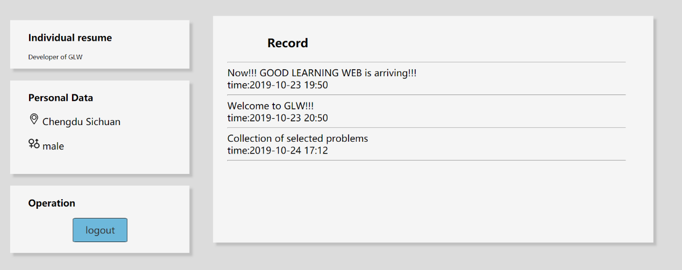

In my design, these blocks should have a same horizontal line, however, from this picture, there is no same horizontal line and I have tried to solve it but it didn’t work. Finally, I just keep them in this form.

**Test and problem:**

In order to test the coursework, I planned to test content first, then test the accessibility and usability in different browsers.

1. **Basic test:**

Firstly, under Smart Lenovo Browser, I test all the links whether they can jump to the correct website. And I also check the color, font size, element, layout and content form.

1. **Accessibility and Usability:**

First, I test it for visually impaired users, through adding this style

” html {

filter: progid:DXImageTransform.Microsoft.BasicImage(grayscale=1);

-webkit-filter: grayscale(100%);

}”.

I make all interface be gray.

Compared:

Normal: 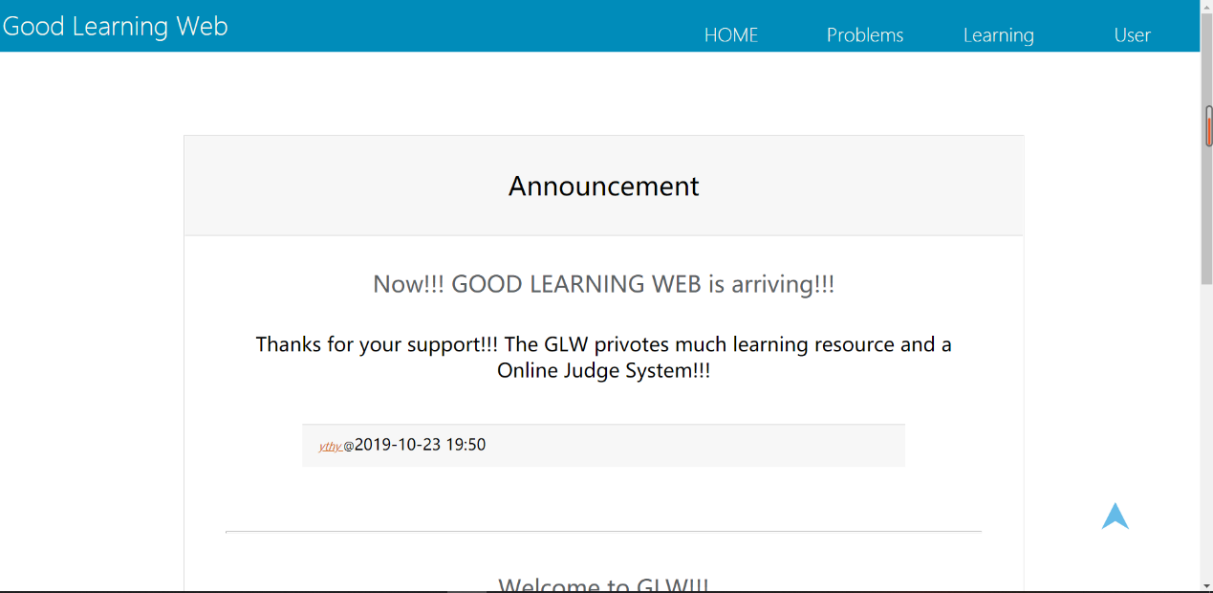

After modification:

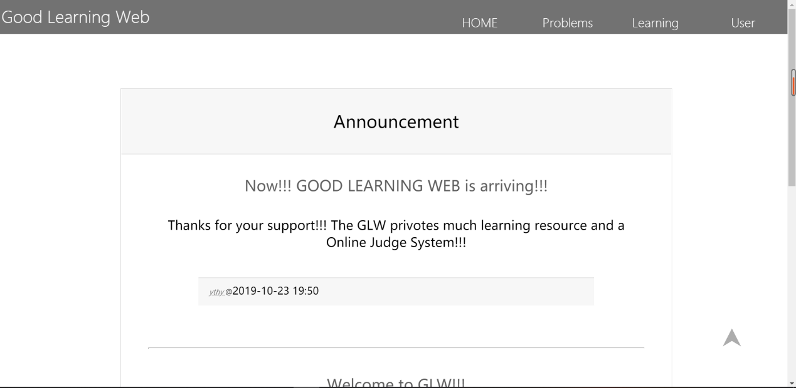

After changing, all the contents can be recognized clearly and easily.

Then I test the pictures’ alt and title.

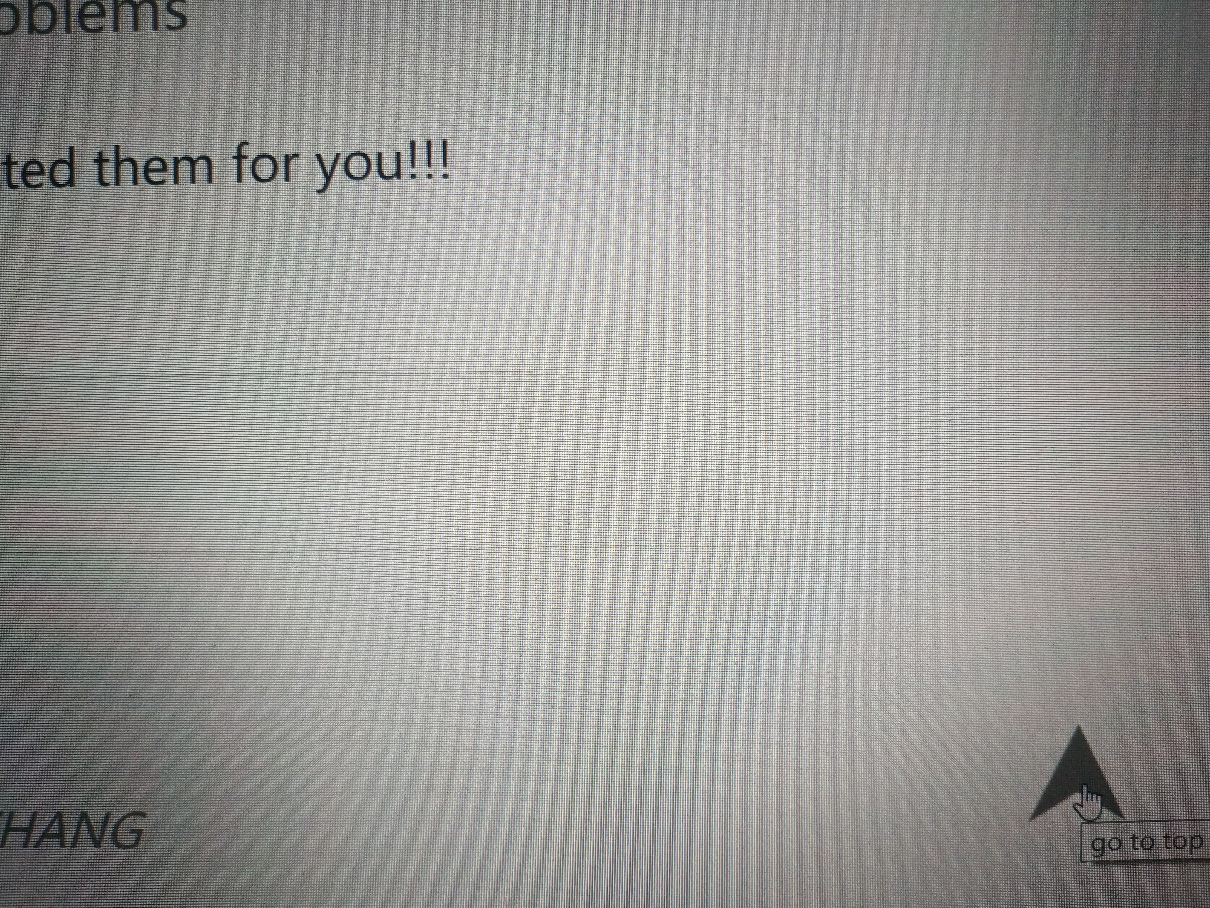

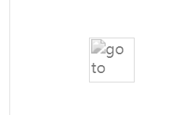

The title and alt are showed correctly.

1. **Browser diﬀerences:**

I Open a webpage with a different browser (Smart Lenovo Browser, 360 Brower, 360 fast Browser, Chrome, Edge and IE).

In the most Browsers, the websites have a correct and satisfying performance. However, in IE there are some errors.

First:

Expected:

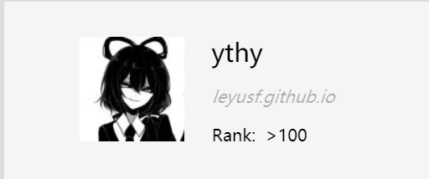

Reality:

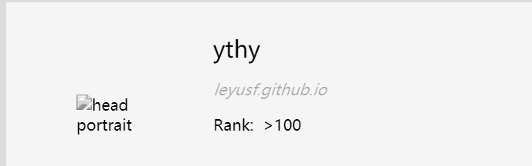

The reason is that this picture is changed to PNG form.

And IE uses the original format of image (JPG), therefore, this picture can’t be loaded.

Then changing the picture form to JPG, this problem is solved.

Second:

Expected:

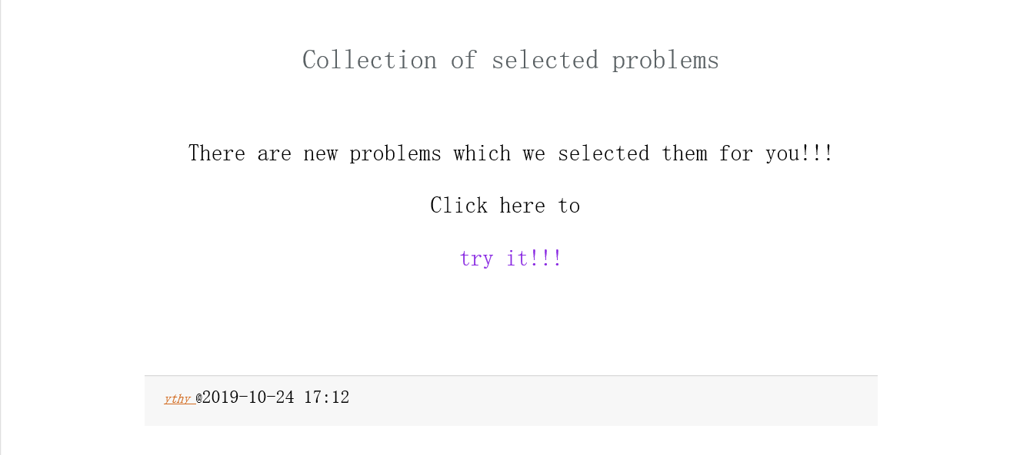

Reality:

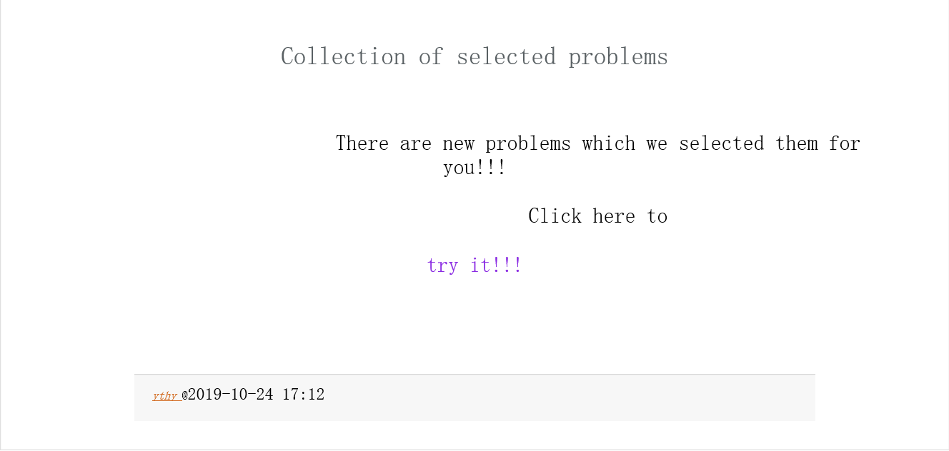

The reason is that IE has no attribution” initial”.

Before I use the style” p {

margin-left: 5%;

white-space:pre-wrap;

}”

And in this block I use the class” p_ok{white-space:initial}” to cancel last style, because IE have no “initial”, the style is not canceled.

To solve this problem, I write content align left.

E.G.

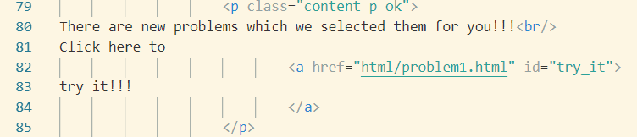

1. **Page size adaptation:**

In 80% - 120%, there is no mistakes.

Evidence:

80%:

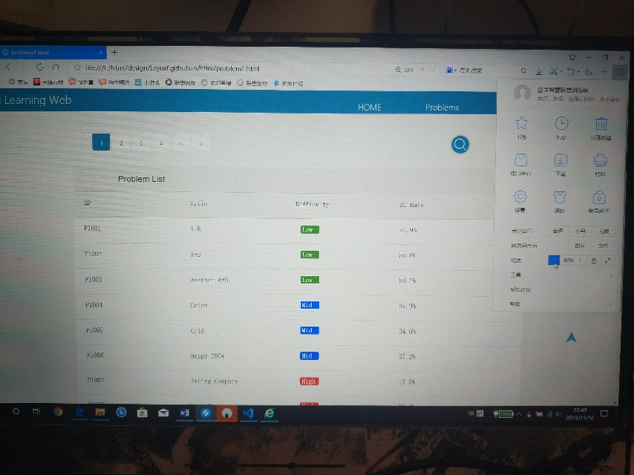

120%:

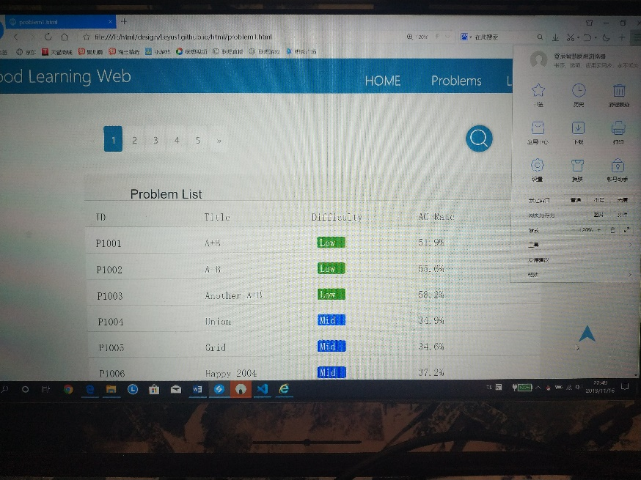

Phone:

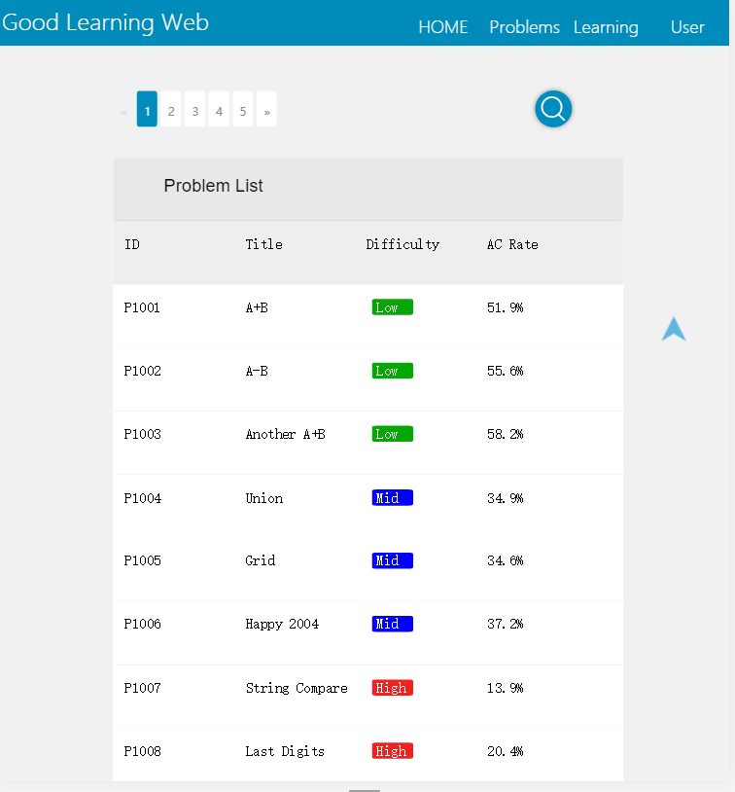

Change the window:

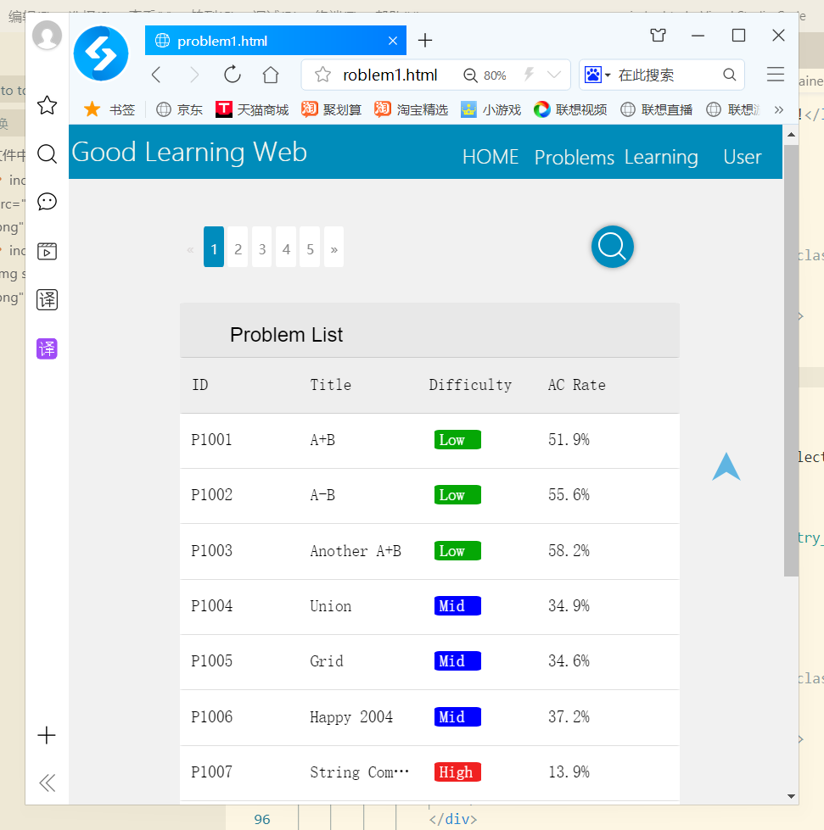

In total, layout and content have no error. Because I didn’t set the font, in different browsers it will show different fonts.

**Reference:**

**Layout and color:**

<https://swjtuoj.cn/>

<https://www.luogu.org/>

https://minerva.leeds.ac.uk/

**Content:**

Problems:

<https://swjtuoj.cn/>

<https://www.luogu.org/>

pictures:

<https://www.iconfont.cn/help/detail?helptype=draw>

<https://image.baidu.com/search/index?tn=baiduimage&ct=201326592&lm=-1&cl=2&ie=gb18030&word=%C2%E5%BE%ED%BE%ED&fr=ala&ala=1&alatpl=adress&pos=0&hs=2&xthttps=111111>